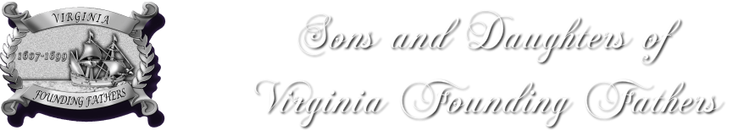

PLACEMENT OF SDVAFF INSIGNIA AND PINS ON OFFICIAL RIBBON

The official ribbon is not to exceed fourteen inches in length and is to be placed on the left shoulder, starting at the shoulder seam. Pins must be placed in the order listed below and ending with the official insignia at the bottom of the ribbon over the heart. When wearing more than one ribbon, the insignia must be placed on the inside ribbon (neck side). The sash ribbon must be worn over the right shoulder and pinned on the left hip. It should not be longer than the garment being worn. Insignia, pins, ribbons and sash are not to be worn in public unless one is officially representing the SDVAFF, or attending the funeral, memorial service, or other services honoring a deceased member. Only ancestral bars, service bars, and/or pins approved and authorized by the Board may be worn with the insignia pin upon the official ribbon.

Top Bar

Original Ancestor Bar

Governor General Pin ~ current or past

General Officer Pin

General Officer Bar ~ most current office on top (first) following the correct order to the oldest office

Founder Member Pin

Charter Member Pin

First 100 Member Pin

Honorary Associate Member Pin

Supplemental Ancestor Bar(s)

Emblem

